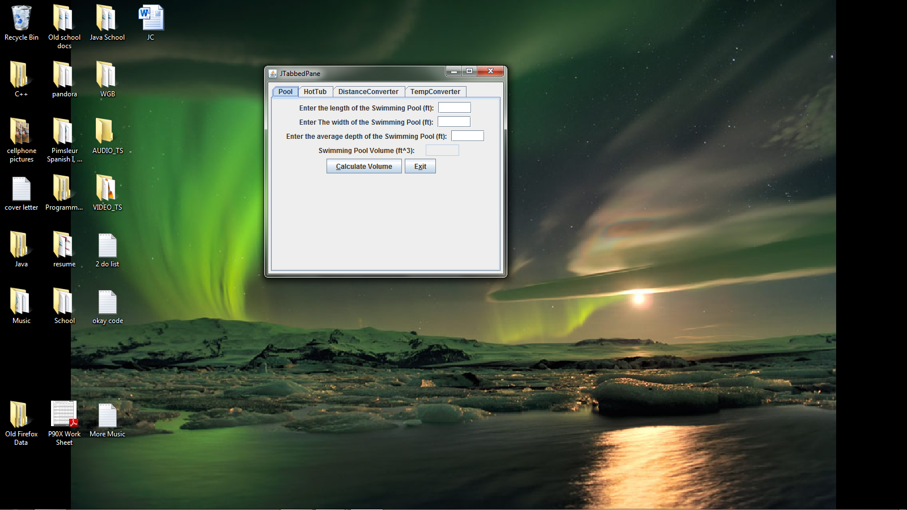

**package** week7;

**import** java.awt.BorderLayout;

**import** java.awt.event.KeyEvent;

**import** javax.swing.JFrame;

**import** javax.swing.JPanel;

**import** javax.swing.JTabbedPane;

**import** javax.swing.SwingUtilities;

@SuppressWarnings("serial")

**public** **class** CourseProject **extends** JPanel

{

**public** CourseProject()

{

**final** JTabbedPane tabbedPane = **new** JTabbedPane();

**final** Pool JTB1 = **new** Pool();

**final** HotTub JTB2 = **new** HotTub();

**final** DistanceConverter JTB3 = **new** DistanceConverter();

**final** TempConverter JTB4 = **new** TempConverter();

//final JPanel JTB2 = new OfficeAreaCalculator();

tabbedPane.add("Pool", JTB1);

tabbedPane.setMnemonicAt(0, KeyEvent.*VK_1*);

tabbedPane.add("HotTub", JTB2);

tabbedPane.setMnemonicAt(0, KeyEvent.*VK_1*);

tabbedPane.add("DistanceConverter", JTB3);

tabbedPane.setMnemonicAt(0, KeyEvent.*VK_1*);

tabbedPane.add("TempConverter", JTB4);

tabbedPane.setMnemonicAt(0, KeyEvent.*VK_1*);

add(tabbedPane);

}

// Create JTabbedPane

**private** **static** **void** createAndShowGUI()

{

// Create and set up the window.

JFrame frame = **new** JFrame("JTabbedPane");

frame.setDefaultCloseOperation(JFrame.*EXIT_ON_CLOSE*);

frame.add(**new** CourseProject(), BorderLayout.*CENTER*);

frame.pack();

frame.setVisible(**true**);

}

**public** **static** **void** main(String[] args)

{

SwingUtilities.*invokeLater*(**new** Runnable()

{

**public** **void** run()

{

*createAndShowGUI*();

}

});

}

}

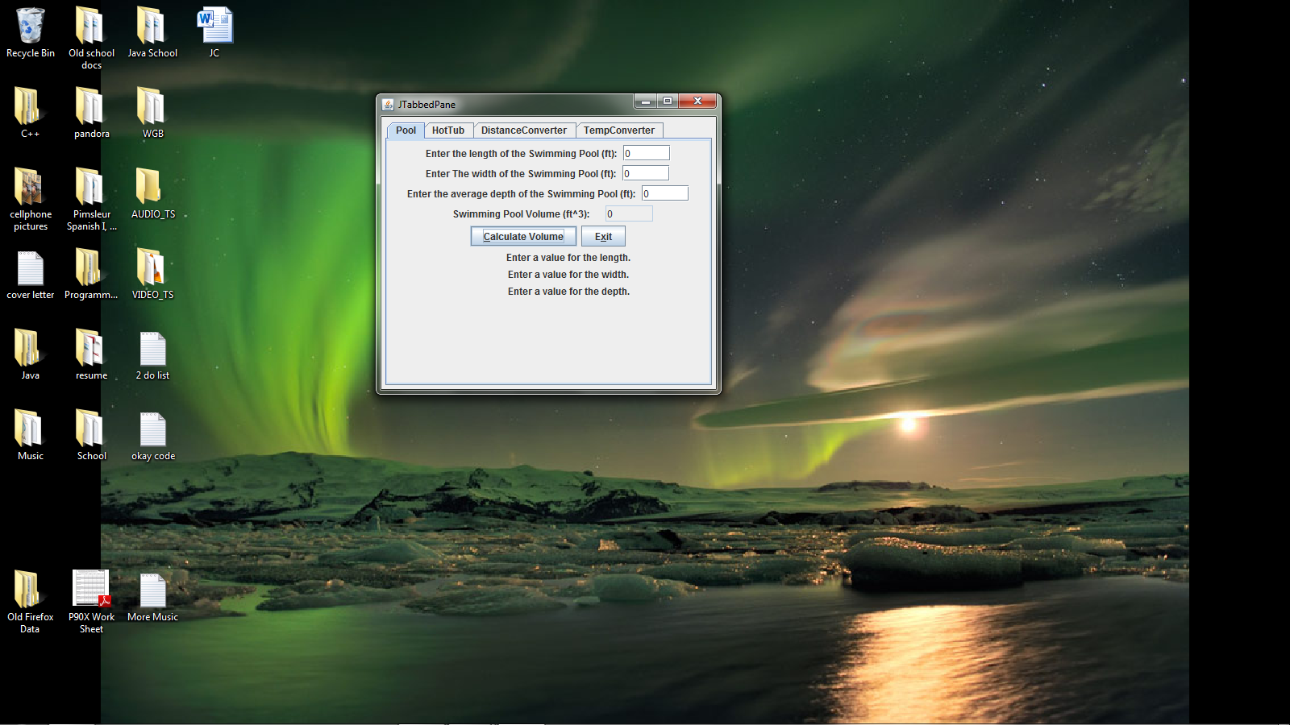

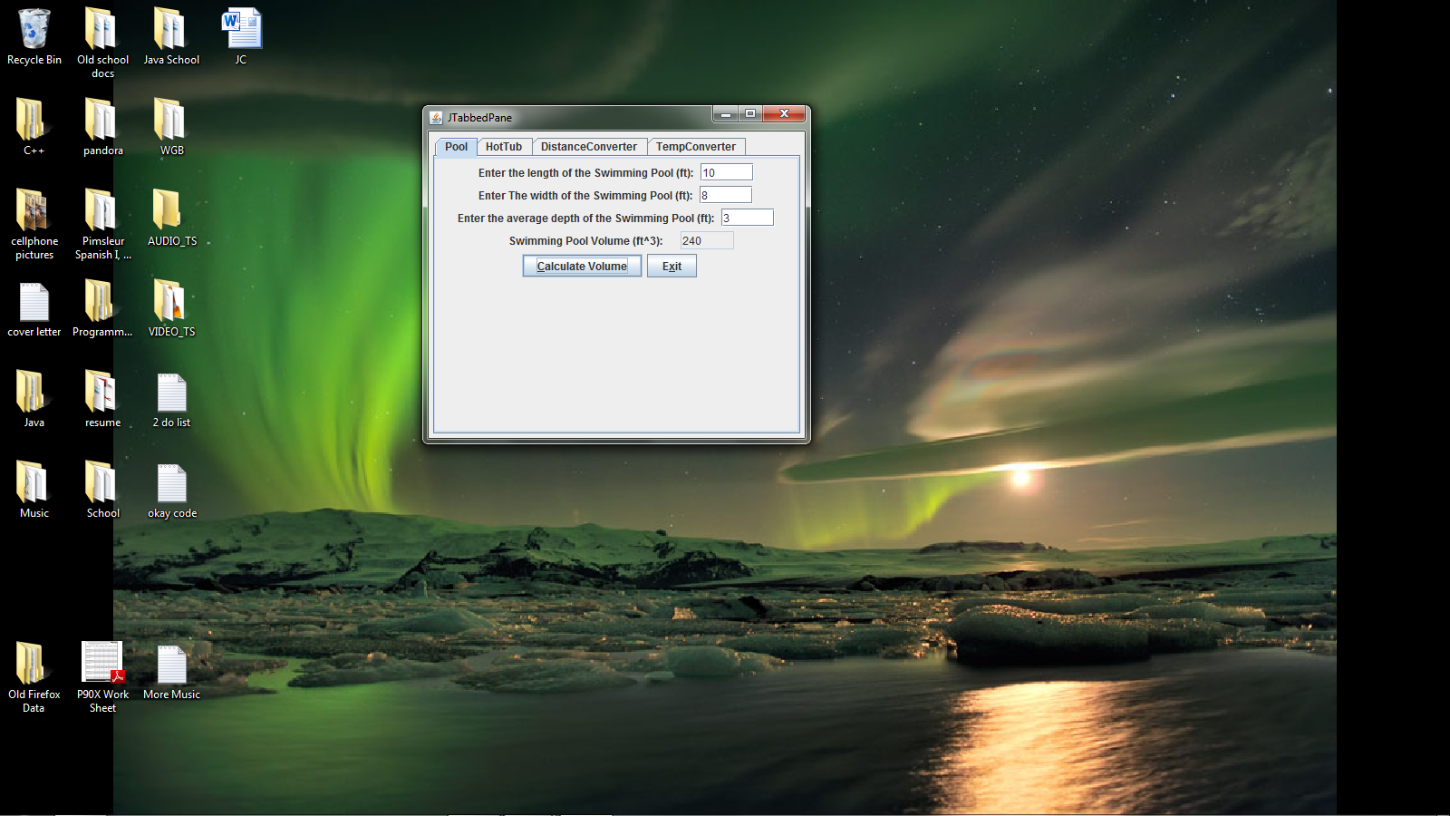

**package** week7;

**import** java.awt.Dimension;

**import** java.awt.FlowLayout;

**import** java.awt.event.ActionEvent;

**import** java.awt.event.ActionListener;

**import** java.awt.event.FocusEvent;

**import** java.awt.event.FocusListener;

**import** java.io.BufferedReader;

**import** java.io.FileReader;

**import** java.io.FileWriter;

**import** java.io.IOException;

**import** java.text.DecimalFormat;

**import** javax.swing.JButton;

**import** javax.swing.JOptionPane;

**import** javax.swing.JPanel;

**import** javax.swing.JLabel;

**import** javax.swing.JTextField;

**public** **class** Pool **extends** JPanel

{

**static** **final** **long** *serialVersionUID* = 1L;

JButton calculatebutton;

JButton exitButton;

JTextField PlengthField;

JTextField PwidthField;

JTextField PdepthField;

JTextField PvolumeField;

JLabel Pdepthlabel;

JLabel Plengthlabel;

JLabel Pwidththlabel;

JLabel Pvolumelabel;

JLabel PErrorwidthlabel;

JLabel PErrorlengthlabel;

JLabel PErrordepthlabel;

**public** Pool()

{

setPreferredSize(**new** Dimension(350, 300));

exitButton = **new** JButton("Exit");

Plengthlabel = **new** JLabel("Enter the length of the Swimming Pool (ft): ");

Pwidththlabel = **new** JLabel("Enter The width of the Swimming Pool (ft): ");

Pdepthlabel = **new** JLabel("Enter the average depth of the Swimming Pool (ft): ");

Pvolumelabel = **new** JLabel(" Swimming Pool Volume (ft^3): ");

PErrordepthlabel = **new** JLabel("");

PErrorwidthlabel = **new** JLabel("");

PErrorlengthlabel = **new** JLabel("");

PlengthField = **new** JTextField(5);

PwidthField = **new** JTextField(5);

PvolumeField = **new** JTextField(5);

PdepthField = **new** JTextField(5);

PvolumeField.setEditable(**false**);

calculatebutton = **new** JButton("Calculate Volume");

setLayout( **new** FlowLayout());

add(Plengthlabel);

add(PlengthField);

add(Pwidththlabel);

add(PwidthField);

add(Pdepthlabel);

add(PdepthField);

add(Pvolumelabel);

add(PvolumeField);

add(calculatebutton);

add(exitButton);

add(PErrorlengthlabel);

add(PErrorwidthlabel);

add(PErrordepthlabel);

calculatebutton.setMnemonic('c');

exitButton.setMnemonic('X');

CalculateButtonHandler chandler = **new** CalculateButtonHandler();

calculatebutton.addActionListener(chandler);

ExitButtonHandler ehandler = **new** ExitButtonHandler();

exitButton.addActionListener(ehandler);

FocusHandler fhandler = **new** FocusHandler();

PlengthField.addFocusListener(fhandler);

PwidthField.addFocusListener(fhandler);

PdepthField.addFocusListener(fhandler);

PvolumeField.addFocusListener(fhandler);

}

**class** CalculateButtonHandler **implements** ActionListener

{

**public** **void** actionPerformed(ActionEvent e)

{

DecimalFormat num = **new** DecimalFormat(",###.##");

**double** width, length, depth, volume;

String inString;

inString = PlengthField.getText();

**if** (inString.equals(""))

{

inString = "0";

PlengthField.setText("0");

PErrorlengthlabel.setText(" Enter a value for the length.");

}

length = Double.*parseDouble*(inString);

inString = PwidthField.getText();

**if** (inString.equals(""))

{

inString = "0";

PwidthField.setText("0");

PErrorwidthlabel.setText(" Enter a value for the width.");

}

width = Double.*parseDouble*(inString);

inString = PdepthField.getText();

**if** (inString.equals(""))

{

inString = "0";

PdepthField.setText("0");

PErrordepthlabel.setText(" Enter a value for the depth.");

}

depth = Double.*parseDouble*(inString);

volume = length * width * depth;

PvolumeField.setText(num.format(volume));

**if**(depth > 0){

PErrordepthlabel.setText("");

}

**if**(length > 0){

PErrorlengthlabel.setText("");

}

**if**(width > 0){

PErrorwidthlabel.setText("");

}

//Will write to the Data.txt file

**try**{

FileWriter fileW = **new** FileWriter("Data.txt");

System.*out*.println("Writing data to Data.txt file");

fileW.write("Pool length:");

fileW.write(PlengthField.getText());

fileW.write(",");

fileW.write(" ");

fileW.write("Pool width:");

fileW.write(PwidthField.getText());

fileW.write(",");

fileW.write(" ");

fileW.write("Pool avg depth:");

fileW.write(PdepthField.getText());

fileW.write(",");

fileW.write(" ");

fileW.write("Pool volume:");

fileW.write(PvolumeField.getText());

fileW.write(",");

fileW.close();

FileReader fileR = **new** FileReader("Data.txt");

BufferedReader buffIn = **new** BufferedReader(fileR);

String textData = buffIn.readLine();

System.*out*.println(textData);

buffIn.close();

System.*out*.println("\n");

}

**catch**(IOException e1)

{

JOptionPane.*showMessageDialog*(**null**,e1.getMessage(), "ERROR",2);

}

}

}

**class** ExitButtonHandler **implements** ActionListener

{

**public** **void** actionPerformed(ActionEvent e)

{

System.*exit*(0);

}

}

**class** FocusHandler **implements** FocusListener

{

**public** **void** focusGained(FocusEvent e)

{

**if** (e.getSource() == PlengthField || e.getSource() == PwidthField || e.getSource() == PdepthField)

{

PvolumeField.setText("");

}

**else** **if** (e.getSource() == PvolumeField)

{

calculatebutton.requestFocus();

}

}

**public** **void** focusLost(FocusEvent e)

{

**if** (e.getSource() == PdepthField)

{

calculatebutton.requestFocus();

}

}

}

**public** **static** **void** main(String args[])

{

Pool pl;

pl = **new** Pool();

}

}

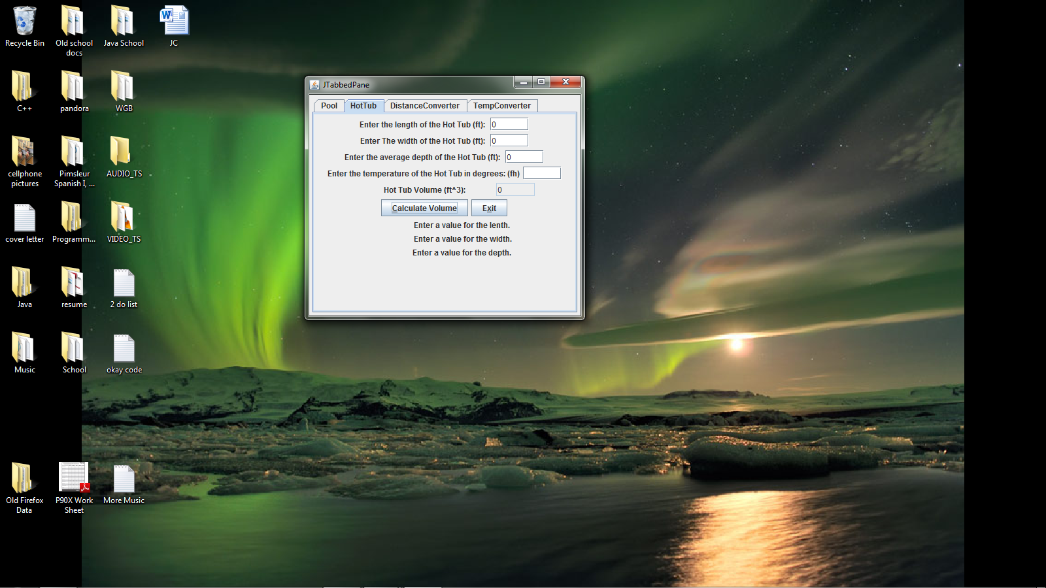

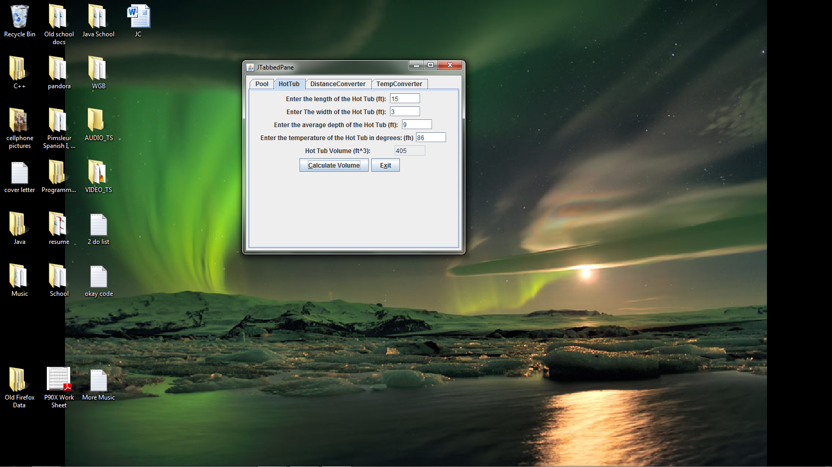

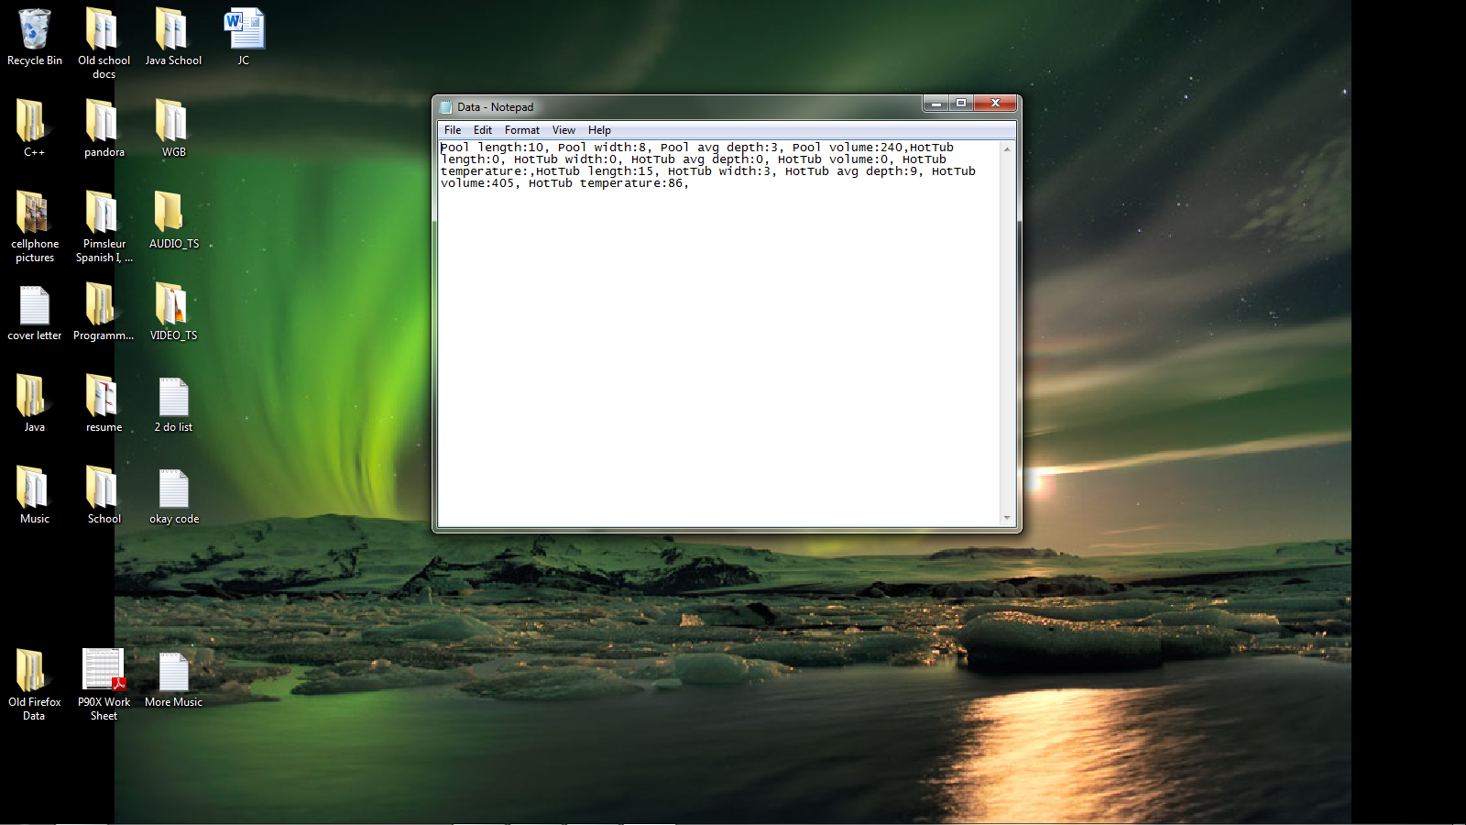

**package** week7;

**import** java.awt.Dimension;

**import** java.awt.FlowLayout;

**import** java.awt.event.ActionEvent;

**import** java.awt.event.ActionListener;

**import** java.awt.event.FocusEvent;

**import** java.awt.event.FocusListener;

**import** java.io.BufferedReader;

**import** java.io.FileReader;

**import** java.io.FileWriter;

**import** java.io.IOException;

**import** java.text.DecimalFormat;

**import** javax.swing.JButton;

**import** javax.swing.JOptionPane;

**import** javax.swing.JPanel;

**import** javax.swing.JLabel;

**import** javax.swing.JTextField;

**public** **class** HotTub **extends** JPanel

{

**static** **final** **long** *serialVersionUID* = 1L;

JButton Hcalculatebutton;

JButton HexitButton;

JTextField HlengthField;

JTextField HwidthField;

JTextField HdepthField;

JTextField HvolumeField;

JLabel Hdepthlabel;

JLabel Hlengthlabel;

JLabel Hwidththlabel;

JLabel Hvolumelabel;

JLabel HErrorwidthlabel;

JLabel HErrorlengthlabel;

JLabel HErrordepthlabel;

JLabel HTemplabel;

JTextField HTempField;

**public** HotTub()

{

setPreferredSize(**new** Dimension(400, 300));

HexitButton = **new** JButton("Exit");

Hlengthlabel = **new** JLabel("Enter the length of the Hot Tub (ft): ");

Hwidththlabel = **new** JLabel("Enter The width of the Hot Tub (ft): ");

Hdepthlabel = **new** JLabel("Enter the average depth of the Hot Tub (ft): ");

HTemplabel = **new** JLabel("Enter the temperature of the Hot Tub in degrees: (fh)");

Hvolumelabel = **new** JLabel(" Hot Tub Volume (ft^3): ");

HErrordepthlabel = **new** JLabel("");

HErrorwidthlabel = **new** JLabel("");

HErrorlengthlabel = **new** JLabel("");

HTempField = **new** JTextField(5);

HlengthField = **new** JTextField(5);

HwidthField = **new** JTextField(5);

HvolumeField = **new** JTextField(5);

HdepthField = **new** JTextField(5);

HvolumeField.setEditable(**false**);

Hcalculatebutton = **new** JButton("Calculate Volume");

setLayout( **new** FlowLayout());

add(Hlengthlabel);

add(HlengthField);

add(Hwidththlabel);

add(HwidthField);

add(Hdepthlabel);

add(HdepthField);

add(HTemplabel);

add(HTempField);

add(Hvolumelabel);

add(HvolumeField);

add(Hcalculatebutton);

add(HexitButton);

add(HErrorlengthlabel);

add(HErrorwidthlabel);

add(HErrordepthlabel);

Hcalculatebutton.setMnemonic('c');

HexitButton.setMnemonic('X');

HcalculatebuttonHandler chandler = **new** HcalculatebuttonHandler();

Hcalculatebutton.addActionListener(chandler);

HexitButtonHandler ehandler = **new** HexitButtonHandler();

HexitButton.addActionListener(ehandler);

FocusHandler fhandler = **new** FocusHandler();

HlengthField.addFocusListener(fhandler);

HwidthField.addFocusListener(fhandler);

HdepthField.addFocusListener(fhandler);

HvolumeField.addFocusListener(fhandler);

}

**class** HcalculatebuttonHandler **implements** ActionListener

{

**public** **void** actionPerformed(ActionEvent e)

{

DecimalFormat num = **new** DecimalFormat(",###.##");

**double** width, length, depth, volume;

String inString;

inString = HlengthField.getText();

**if** (inString.equals(""))

{

inString = "0";

HlengthField.setText("0");

HErrorlengthlabel.setText(" Enter a value for the lenth.");

}

length = Double.*parseDouble*(inString);

inString = HwidthField.getText();

**if** (inString.equals(""))

{

inString = "0";

HwidthField.setText("0");

HErrorwidthlabel.setText(" Enter a value for the width.");

}

width = Double.*parseDouble*(inString);

inString = HdepthField.getText();

**if** (inString.equals(""))

{

inString = "0";

HdepthField.setText("0");

HErrordepthlabel.setText(" Enter a value for the depth.");

}

depth = Double.*parseDouble*(inString);

volume = length * width * depth;

HvolumeField.setText(num.format(volume));

**if**(depth > 0){

HErrordepthlabel.setText("");

}

**if**(length > 0){

HErrorlengthlabel.setText("");

}

**if**(width > 0){

HErrorwidthlabel.setText("");

}

//Will write to the Data.txt file

**try**{

FileWriter fileW = **new** FileWriter("Data.txt", **true**);

System.*out*.println("Writing data to Data.txt file");

fileW.write("\nHotTub length:");

fileW.write(HlengthField.getText());

fileW.write(",");

fileW.write(" ");

fileW.write("HotTub width:");

fileW.write(HwidthField.getText());

fileW.write(",");

fileW.write(" ");

fileW.write("HotTub avg depth:");

fileW.write(HdepthField.getText());

fileW.write(",");

fileW.write(" ");

fileW.write("HotTub volume:");

fileW.write(HvolumeField.getText());

fileW.write(",");

fileW.write(" ");

fileW.write("HotTub temperature:");

fileW.write(HTempField.getText());

fileW.write(",");

fileW.close();

FileReader fileR = **new** FileReader("Data.txt");

BufferedReader buffIn = **new** BufferedReader(fileR);

String textData = buffIn.readLine();

System.*out*.println(textData);

buffIn.close();

System.*out*.println("\n");

}

**catch**(IOException e1)

{

JOptionPane.*showMessageDialog*(**null**,e1.getMessage(), "ERROR",2);

}

}

}

**class** HexitButtonHandler **implements** ActionListener

{

**public** **void** actionPerformed(ActionEvent e)

{

System.*exit*(0);

}

}

**class** FocusHandler **implements** FocusListener

{

**public** **void** focusGained(FocusEvent e)

{

**if** (e.getSource() == HlengthField || e.getSource() == HwidthField || e.getSource() == HdepthField || e.getSource() == HTempField)

{

HvolumeField.setText("");

}

**else** **if** (e.getSource() == HvolumeField)

{

Hcalculatebutton.requestFocus();

}

}

**public** **void** focusLost(FocusEvent e)

{

**if** (e.getSource() == HdepthField)

{

Hcalculatebutton.requestFocus();

}

}

}

**public** **static** **void** main(String args[])

{

@SuppressWarnings("unused")

HotTub ht;

ht = **new** HotTub();

}

}

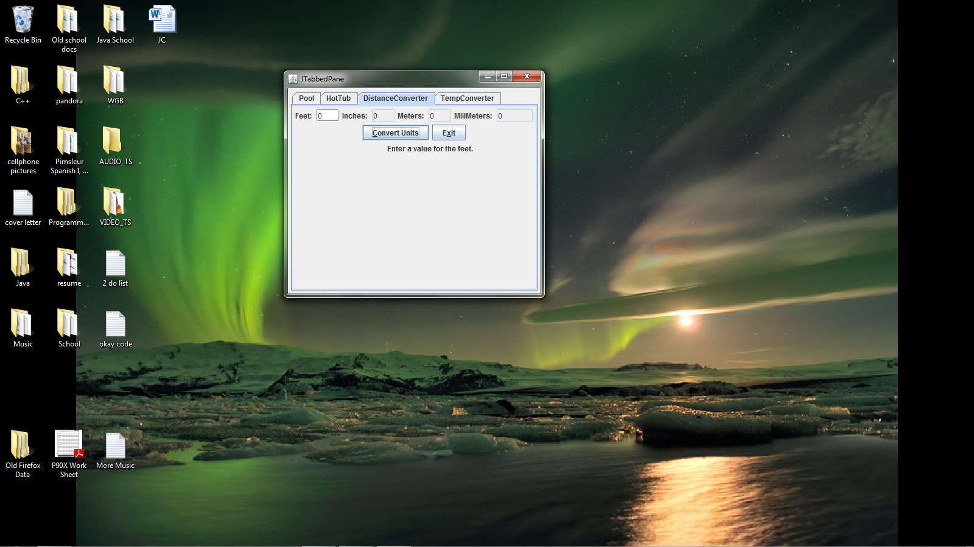

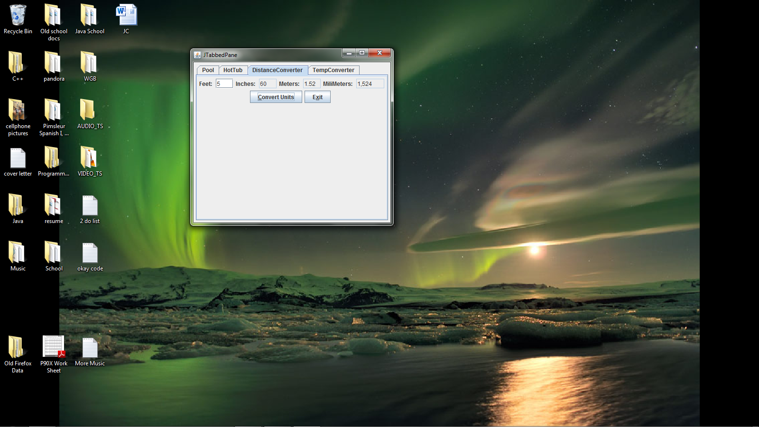

**package** week7;

**import** java.awt.Dimension;

**import** java.awt.FlowLayout;

**import** java.awt.event.ActionEvent;

**import** java.awt.event.ActionListener;

**import** java.awt.event.FocusEvent;

**import** java.awt.event.FocusListener;

**import** java.text.DecimalFormat;

**import** javax.swing.JButton;

**import** javax.swing.JPanel;

**import** javax.swing.JLabel;

**import** javax.swing.JTextField;

**public** **class** DistanceConverter **extends** JPanel

{

**static** **final** **long** *serialVersionUID* = 1L;

JButton Ccalculatebutton;

JButton CexitButton;

JTextField CMeterField;

JTextField CFeetField;

JTextField CMiliMetersField;

JTextField CInchesField;

JLabel CMeterlabel;

JLabel CFeetlabel;

JLabel CMiliMeterslabel;

JLabel CIncheslabel;

JLabel CErrorFeet;

**public** DistanceConverter()

{

setPreferredSize(**new** Dimension(400, 300));

CexitButton = **new** JButton("Exit");

CFeetlabel = **new** JLabel("Feet: ");

CMiliMeterslabel = **new** JLabel("MiliMeters: ");

CMeterlabel = **new** JLabel("Meters: ");

CIncheslabel = **new** JLabel("Inches: ");

CErrorFeet = **new** JLabel("");

CMeterField = **new** JTextField(3);

CFeetField = **new** JTextField(3);

CInchesField = **new** JTextField(3);

CMiliMetersField = **new** JTextField(5);

CInchesField.setEditable(**false**);

CMeterField.setEditable(**false**);

CMiliMetersField.setEditable(**false**);

Ccalculatebutton = **new** JButton("Convert Units");

setLayout( **new** FlowLayout());

add(CFeetlabel);

add(CFeetField);

add(CIncheslabel);

add(CInchesField);

add(CMeterlabel);

add(CMeterField);

add(CMiliMeterslabel);

add(CMiliMetersField);

add(Ccalculatebutton);

add(CexitButton);

add(CErrorFeet);

Ccalculatebutton.setMnemonic('c');

CexitButton.setMnemonic('X');

CcalculatebuttonHandler chandler = **new** CcalculatebuttonHandler();

Ccalculatebutton.addActionListener(chandler);

CexitButtonHandler ehandler = **new** CexitButtonHandler();

CexitButton.addActionListener(ehandler);

FocusHandler fhandler = **new** FocusHandler();

CMeterField.addFocusListener(fhandler);

CFeetField.addFocusListener(fhandler);

CMiliMetersField.addFocusListener(fhandler);

CInchesField.addFocusListener(fhandler);

}

**class** CcalculatebuttonHandler **implements** ActionListener

{

**public** **void** actionPerformed(ActionEvent e)

{

DecimalFormat num = **new** DecimalFormat(",###.##");

**double** feet, inches, meters, milimeters;

String inString;

inString = CFeetField.getText();

**if** (inString.equals(""))

{

inString = "0";

CFeetField.setText("0");

CErrorFeet.setText(" Enter a value for the feet. ");

}

feet = Double.*parseDouble*(inString);

**if**(feet > 0){

CErrorFeet.setText("");

}

inches = Double.*parseDouble*(inString);

inches = feet * 12;

meters = feet * 0.3048;

milimeters = feet * 304.8;

CInchesField.setText(num.format(inches));

CMeterField.setText(num.format(meters));

CMiliMetersField.setText(num.format(milimeters));

}

}

**class** CexitButtonHandler **implements** ActionListener

{

**public** **void** actionPerformed(ActionEvent e)

{

System.*exit*(0);

}

}

**class** FocusHandler **implements** FocusListener

{

**public** **void** focusGained(FocusEvent e)

{

**if** (e.getSource() == CMeterField || e.getSource() == CFeetField || e.getSource() == CMiliMetersField)

{

CInchesField.setText("");

}

**else** **if** (e.getSource() == CInchesField)

{

Ccalculatebutton.requestFocus();

}

}

**public** **void** focusLost(FocusEvent e)

{

**if** (e.getSource() == CMiliMetersField)

{

Ccalculatebutton.requestFocus();

}

}

}

**public** **static** **void** main(String args[])

{

@SuppressWarnings("unused")

DistanceConverter DC;

DC = **new** DistanceConverter();

}

}

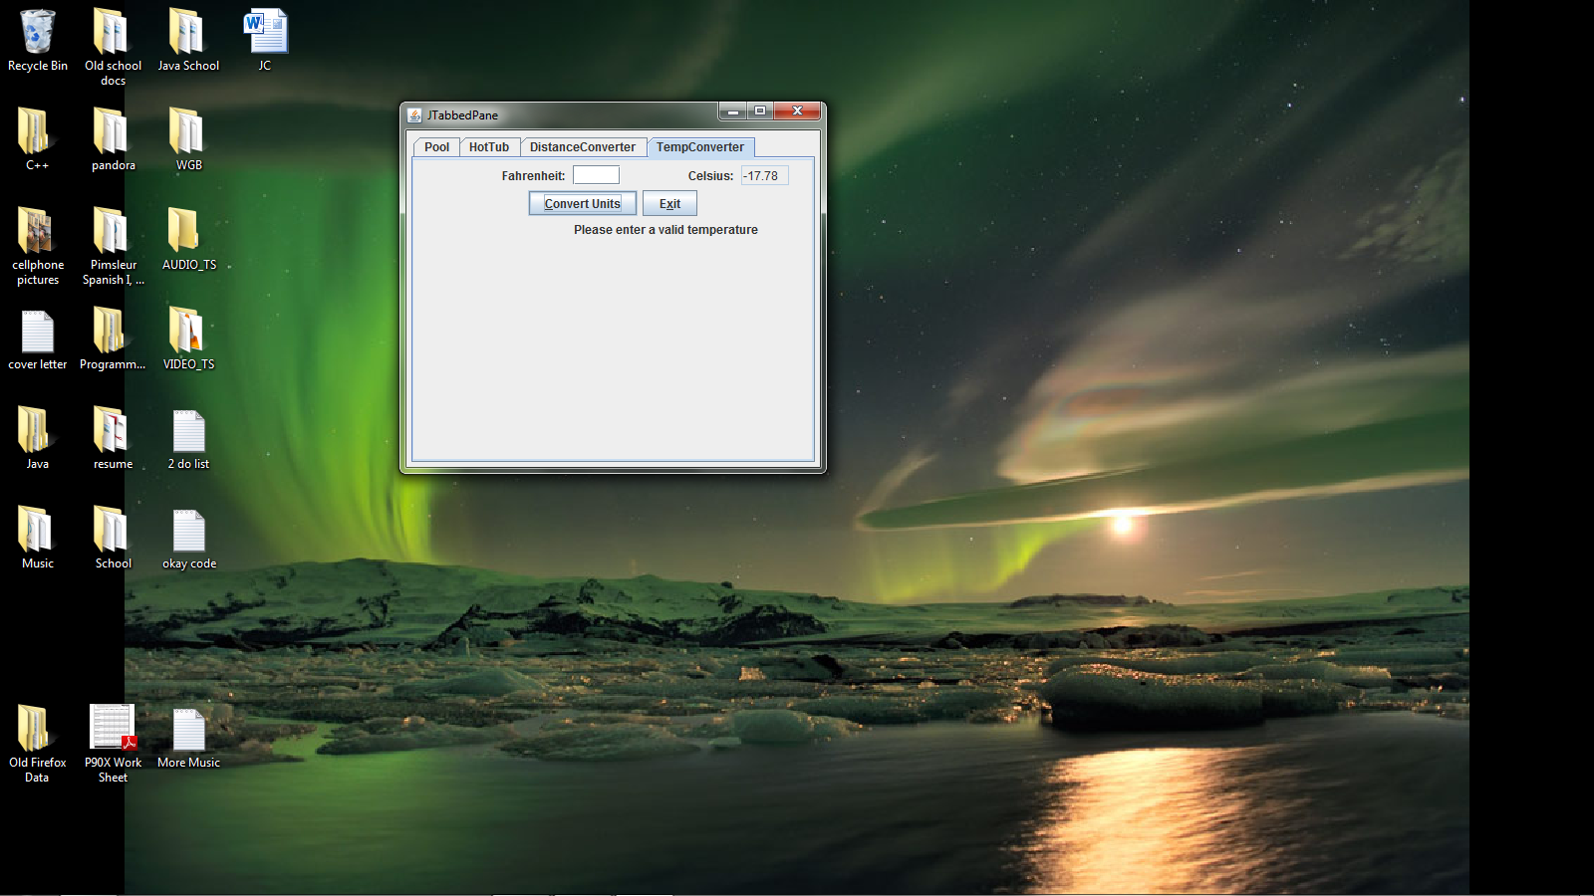

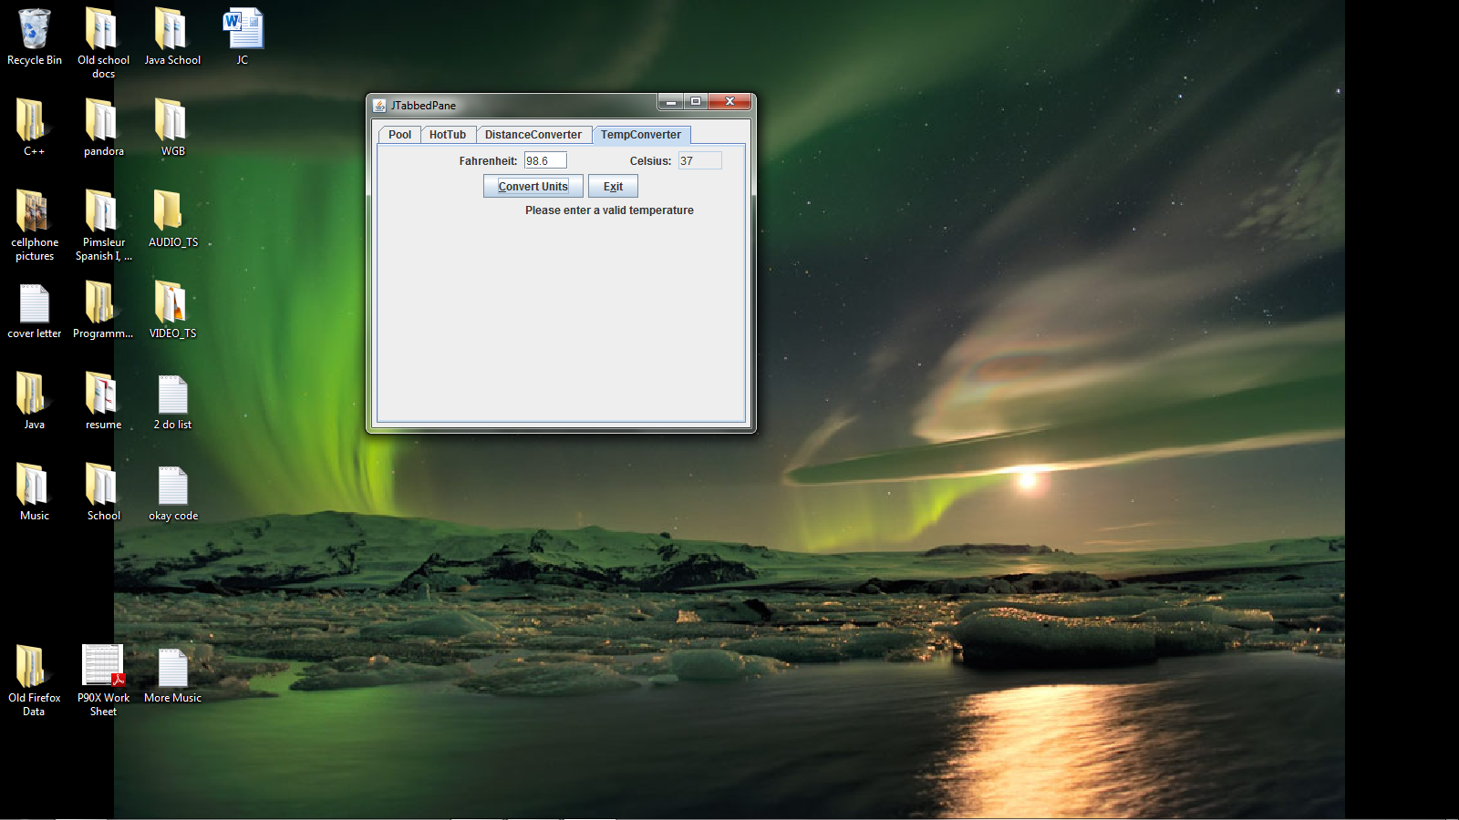

**package** week7;

**import** java.awt.Dimension;

**import** java.awt.FlowLayout;

**import** java.awt.event.ActionEvent;

**import** java.awt.event.ActionListener;

**import** java.awt.event.FocusEvent;

**import** java.awt.event.FocusListener;

**import** java.text.DecimalFormat;

**import** javax.swing.JButton;

**import** javax.swing.JPanel;

**import** javax.swing.JLabel;

**import** javax.swing.JTextField;

**public** **class** TempConverter **extends** JPanel

{

**static** **final** **long** *serialVersionUID* = 1L;

JButton Tcalculatebutton;

JButton TexitButton;

JTextField TFahrenheitField;

JTextField TcelsiusField;

JLabel TFahrenheitlabel;

JLabel Tcelsiuslabel;

JLabel CErrorFahrenheit;

**public** TempConverter()

{

setPreferredSize(**new** Dimension(400, 300));

TexitButton = **new** JButton("Exit");

Tcelsiuslabel = **new** JLabel(" Celsius: ");

TFahrenheitlabel = **new** JLabel(" Fahrenheit: ");

TFahrenheitField = **new** JTextField(4);

TcelsiusField = **new** JTextField(4);

CErrorFahrenheit = **new** JLabel("");

TcelsiusField.setEditable(**false**);

Tcalculatebutton = **new** JButton("Convert Units");

setLayout( **new** FlowLayout());

add(TFahrenheitlabel);

add(TFahrenheitField);

add(Tcelsiuslabel);

add(TcelsiusField);

add(Tcalculatebutton);

add(TexitButton);

add(CErrorFahrenheit);

Tcalculatebutton.setMnemonic('c');

TexitButton.setMnemonic('X');

TcalculatebuttonHandler chandler = **new** TcalculatebuttonHandler();

Tcalculatebutton.addActionListener(chandler);

TexitButtonHandler ehandler = **new** TexitButtonHandler();

TexitButton.addActionListener(ehandler);

FocusHandler fhandler = **new** FocusHandler();

TFahrenheitField.addFocusListener(fhandler);

TcelsiusField.addFocusListener(fhandler);

}

**class** TcalculatebuttonHandler **implements** ActionListener

{

**public** **void** actionPerformed(ActionEvent e)

{

DecimalFormat num = **new** DecimalFormat(",###.##");

**double** fahrenheit, celsius;

String inString;

inString = TFahrenheitField.getText();

**if** (inString.equals(""))

{

inString = "0";

TcelsiusField.setText("0");

CErrorFahrenheit.setText(" Please enter a valid temperature");

}

fahrenheit = Double.*parseDouble*(inString);

celsius = ((fahrenheit - 32) * 5) / 9;

TcelsiusField.setText(num.format(celsius));

}

}

**class** TexitButtonHandler **implements** ActionListener

{

**public** **void** actionPerformed(ActionEvent e)

{

System.*exit*(0);

}

}

**class** FocusHandler **implements** FocusListener

{

**public** **void** focusGained(FocusEvent e)

{

**if** (e.getSource() == TFahrenheitField || e.getSource() == TcelsiusField)

{

TFahrenheitField.setText("");

}

**else** **if** (e.getSource() == TcelsiusField)

{

Tcalculatebutton.requestFocus();

}

}

**public** **void** focusLost(FocusEvent e)

{

**if** (e.getSource() == TFahrenheitField)

{

Tcalculatebutton.requestFocus();

}

}

}

**public** **static** **void** main(String args[])

{

@SuppressWarnings("unused")

TempConverter TC;

TC = **new** TempConverter();

}

}